**7.1**

I could apply exponential smoothing to my cycling power output data to determine whether my training is effective. I track my average power outputs over various of time periods, and ideally these should be increasing if the training is effective. However, there is a lot of variation in daily output based on things like rest, nutrition, weight and where I am in my monthly and annual training cycles.

I would need at least a few years’ worth of power output data. Ideally I would also have data on my sleep, weight, and calorie intake so I could compare them to the smoothed data and see how strongly any of them correlated to periods of good performance.

The Alpha would probably be closer to 0 than 1, as the data is fairly noisy and would need a decent amount of smoothing.

**7.2**

Please review the included R file (7.2.R) and Excel file (seasonality.xlsx) along with this submission.

First, I converted the temperature data into a single vector, then converted that to a time series object for use in the Holt Winters model. I ran the Holt Winters model on the data, using Alpha, Beta, and Gamma factors and multiplicative seasonality. This should better capture the non-linearity of the data than an additive model.

The model found the best fit with the following alpha, beta, and gamma values:

alpha: 0.615003

beta : 0

gamma: 0.5495256

A plot of the original data and smoothed temperature data using those values is below:

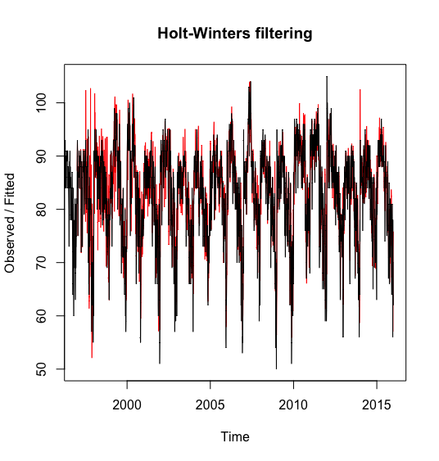

I also plotted the fitted factors:

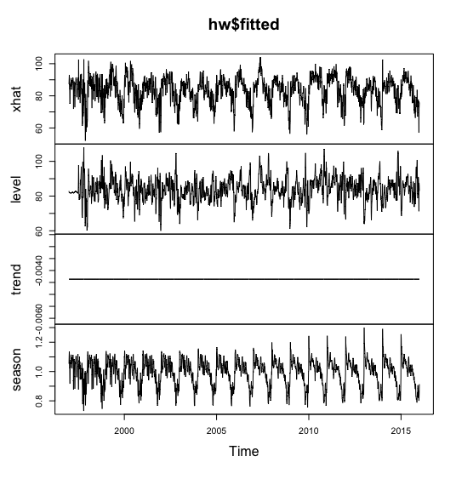

Interestingly, the best fit did not include any smoothing for trend. The seasonality factor looks to have higher peaks in later years. I stored this data in a separate vector and plotted it.

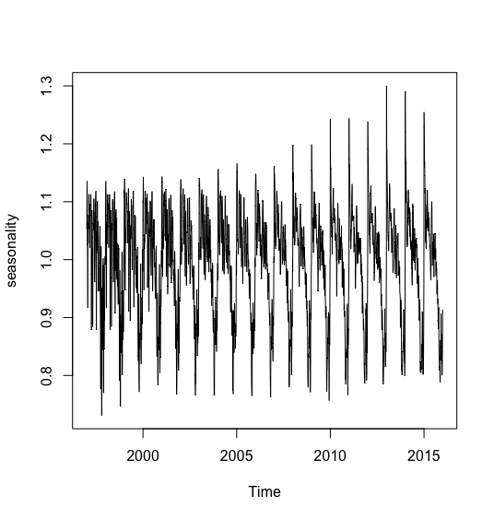

Although this doesn’t indicate that summers are ending later in those years, it does indicate that temperature highs and lows throughout the time period we are analyzing appear to have more variability.

I then converted the seasonality vector into separate columns for each year, and exported the data so I could apply my excel CUSUM model. With the seasonality data loaded in excel, I applied a similar CUSUM analysis as in last week’s analysis. I used a Mu value equal to the mean temperature for the month of July. I used a C value of (.5 * standard deviation) and a T of (5 * standard deviation). With these values the CUSUM model detected a change between September 22 and September 26th each year.

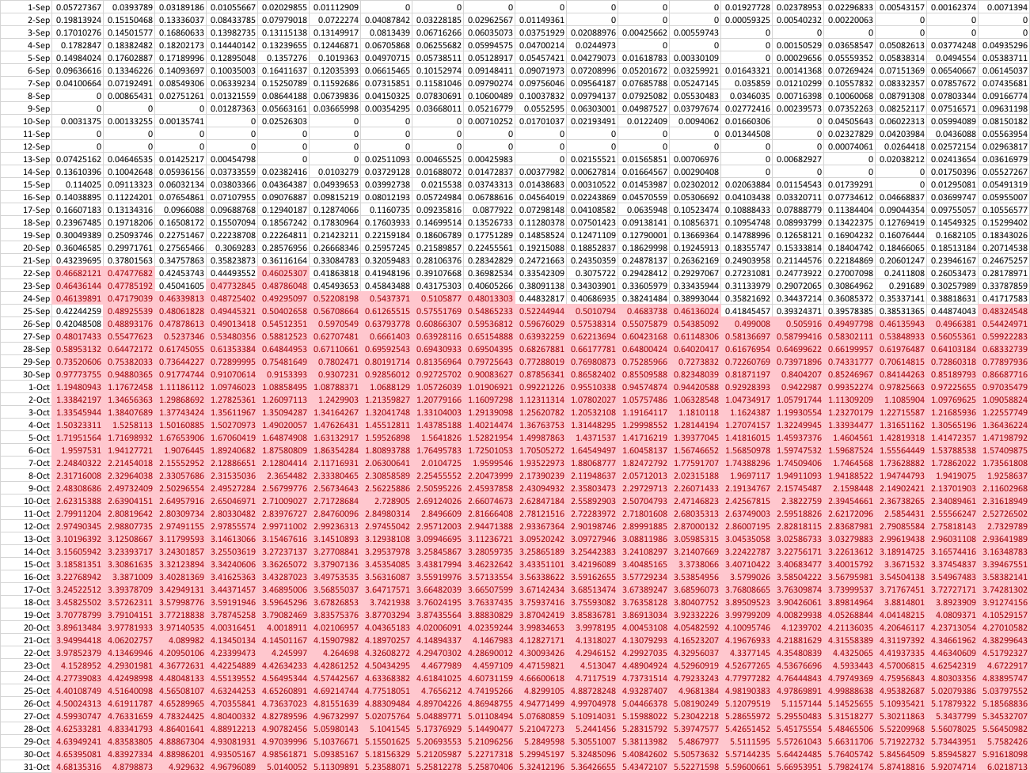

The results are much smoother than when using the raw temperature data, where I found an end to summer within a wide range from early September to early October without a clear trend of later summer end dates. There is also a trend towards later summer end dates, with a shift from September 22nd to September 26th occurring over the time period.



Although I do think this gives a clearer indication of a trend to later summer end dates than last weeks’ results did, I still don’t think it is enough to conclusively state that summer end dates are getting later. We just don’t have enough data to make a conclusion about something that would be happening gradually over such a long time period.